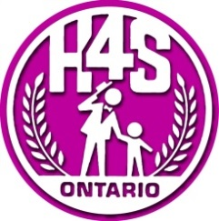
CONSENT TO TREATMENT

I, , as the client/parent/legal guardian, hereby consent under the Health Care Consent Act, S.O. 1996, for myself, child, my spouse (please circle one) , to receive speech-language services in the form of a speech-language screening and/or speech-language therapy from the Communicative Disorders Assistant (CDA) students at Georgian College’s Harmonize for Speech, Hearing and Language Clinic (hereinafter referred to as “clinic”). I understand that treatment is being provided by the CDA students under the supervision of the clinic’s Speech-Language Pathologist. The clinic’s Speech-Language Pathologist is a member in good standing with the College of Audiologists and Speech-Language Pathologists of Ontario. The clinic’s Speech-Language Pathologist will conduct a review of the previous speech-language assessment(s) and speech-language interventions in order to give direction to the CDA students for the purposes of speech-language therapy intervention. The clinic’s Speech-Language Pathologist may adjust goals as deemed necessary based on the collection and analysis of information done by the CDA students during therapy with me or my child.
I understand that my information may be used for educational purposes within the confines of the clinic. I understand that this consent is valid for as long as speech-language services are received at the Harmonize for Speech, Hearing and Language Clinic.
Name of client:
Signature of client/parent/guardian:
Relationship to client:
Witness:
Date:

