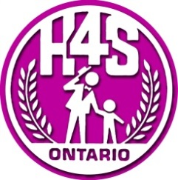
CONSENT TO TREATMENT

I, , as the client/parent/legal guardian, hereby consent under the Health Care Consent Act, S.O. 1996, for myself, child, my spouse (please circle one) , to receive audiology services from the Communicative Disorders Assistant (CDA) students at Georgian College’s Harmonize for Speech, Hearing and Language Clinic (hereinafter referred to as “clinic”). I understand that the audiology service is being provided by the CDA students under the supervision of the clinic’s Audiologist. The clinic’s Audiologist is a member in good standing with the College of Audiologists and Speech Language Pathologists of Ontario. The clinic’s Audiologist will direct the CDA students to complete any or all of the following tasks: conduct audiology screenings without interpretation beyond pass/fail; perform technical components of audiology procedures without interpretation of results; amplification orientation (e.g., general information pertaining to amplification use and maintenance); simple hearing aid and hearing aid-related repairs. The clinic’s Audiologist will interpret and communicate the assessment results to the legal guardian/parent and provide recommendations for treatment.
I understand that my child’s information may be used for educational purposes within the confines of the clinic. I understand that this consent is valid for as long as my child is receiving audiology services at the Harmonize for Speech, Hearing and Language Clinic.
Name of client:
Name of parent/legal guardian:
Signature of client/parent/legal guardian:
Relationship to client (if applicable):
Witness:
Date:

